**Unit 4.1 Visual Design Challenge**

Dennis Clement

Post University

CIS 311_30 Technical Writing in CIS

Dr. Matthew Zullo

September 18th, 2025

|  |  |  |  |  |  |
| --- | --- | --- | --- | --- | --- |
| World Production of Oranges in thousands of Metric tons | | | | | |
|  | 2017 | 2018 | 2019 | 2020 | 2021 |
| Brazil | 12,053 | 13,165 | 15,482 | 16,982 | 18,998 |
| United States | 8,562 | 7,453 | 9,321 | 6,349 | 4,500 |
| China | 8,391 | 4,555 | 7,397 | 8,921 | 7,507 |
| European Union | 4,563 | 4,871 | 4,989 | 5,551 | 6,603 |
| India | 8,776 | 9,091 | 8,898 | 9,769 | 10,806 |
| Mexico | 4,898 | 3,777 | 2,992 | 3,878 | 4,003 |
| Spain | 3,325 | 2,671 | 2,906 | 3,287 | 3,422 |
| Egypt | 1,784 | 2,117 | 2,453 | 2,643 | 2,900 |

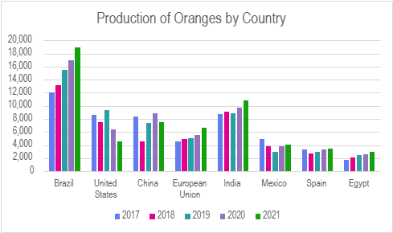

The table and chart called "World Production of Oranges in Thousands of Metric Tons" illustrate how the amount of oranges grown in key producing countries varied from 2017 to 2021. Brazil is consistently the top producer, and its output has continuously climbed from 12,053 thousand metric tons in 2017 to over 19,000 in 2021. This reveals that Brazil is still the most important country in the world for growing citrus. The United States, on the other hand, had a big decline, going from 8,562 to 4,500 thousand metric tons in the same time frame. This was largely because of diseases and changes in farming conditions. India and the EU increased at a consistent rate, but China's growth was uneven, peaking in 2020 and then falling again in 2021. The data as a whole show that the world is changing: Brazil is becoming more powerful, while older producers like the U.S. suffer huge declines, and newer producers like India slowly increase their contributions.